**Q-1. Write an SQL query to fetch “FIRST_NAME” from the Worker table using the alias name <WORKER_NAME>.**

**Ans:-**  select First_name as "Worker_Name" from worker;

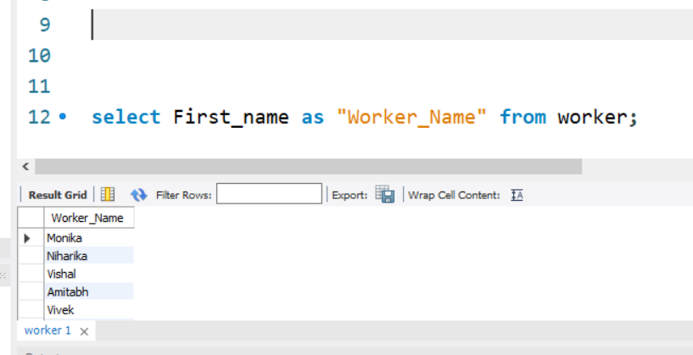

**Q-2. Write an SQL query to fetch “FIRST_NAME” from the Worker table in upper case.**

**Ans:-** select upper(first_name) from worker;

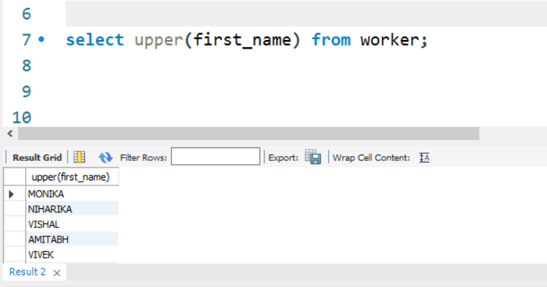

**Q-3. Write an SQL query to fetch unique values of DEPARTMENT from the Worker table.**

**Ans:-** select distinct department from worker;

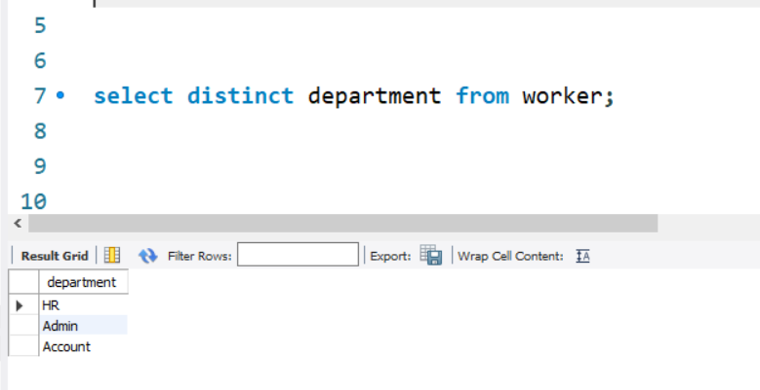

**Q-4. Write an SQL query to print the first three characters of  FIRST_NAME from the Worker table.**

**Ans:-** select substring(first_name,1,3) from worker;

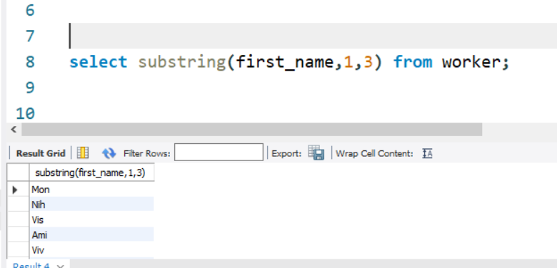

**Q-5. Write an SQL query to find the position of the alphabet (‘a’) in the first name column ‘Amitabh’ from the Worker table.**

**Ans:-** select instr(first_name,'a') from worker where First_name='Amitabh';

**Q-6. Write an SQL query to print the FIRST_NAME from the Worker table after removing white spaces from the right side.**

**Ans**:- select rtrim(first_name) as "Right_Trimmed" from worker ;

**Q-7. Write an SQL query to print the DEPARTMENT from the Worker table after removing white spaces from the left side.**

**Ans:-** select distinct ltrim(Department) as "left_Trimmed" from worker ;

**Q-8. Write an SQL query that fetches the unique values of DEPARTMENT from the Worker table and prints its length.**

**Ans:-** select distinct Department,length(department) as "left_Trimmed" from worker ;

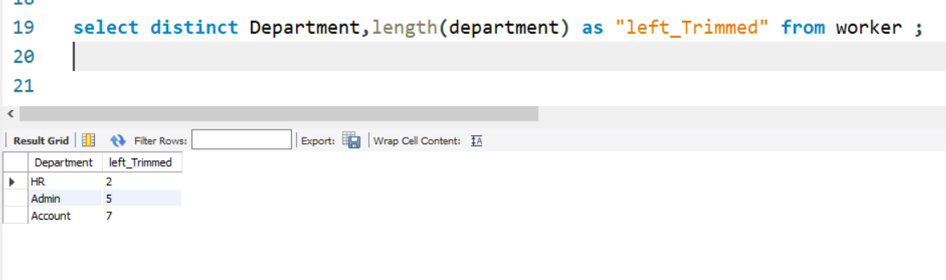

**Q-9. Write an SQL query to print the FIRST_NAME from the Worker table after replacing ‘a’ with ‘A’.**

**Ans:-** select Replace(first_name,'a','A') as "left_Trimmed" from worker ;

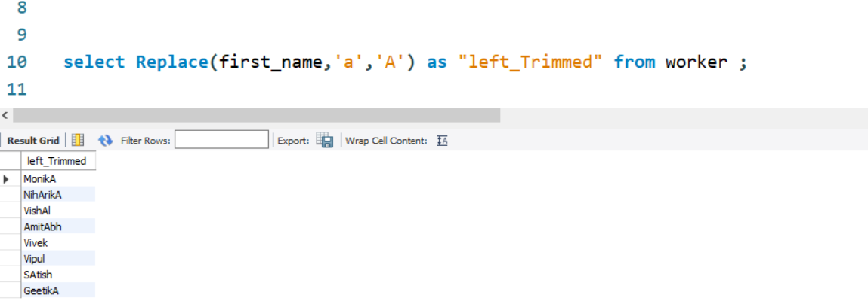

**Q-10. Write an SQL query to print the FIRST_NAME and LAST_NAME from the Worker table into a single column COMPLETE_NAME. A space char should separate them.**

**Ans:-** select concat(first_name,' ',last_name) as "COMPLETE_NAME"from worker;

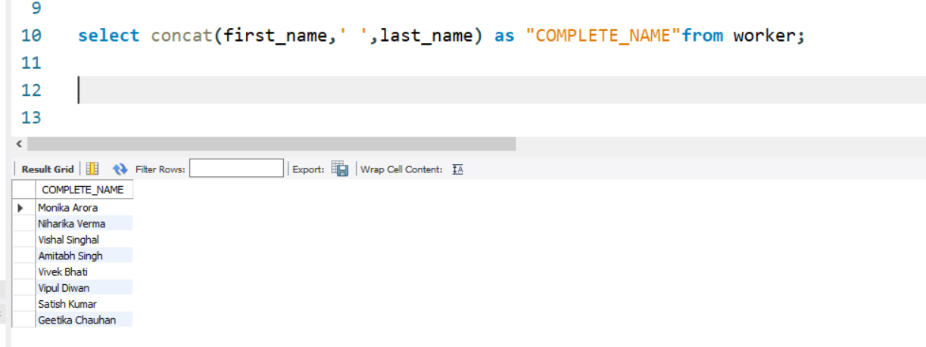

**Q-11. Write an SQL query to print all Worker details from the Worker table order by FIRST_NAME Ascending.**

**Ans:-** select * from worker order by First_Name asc;

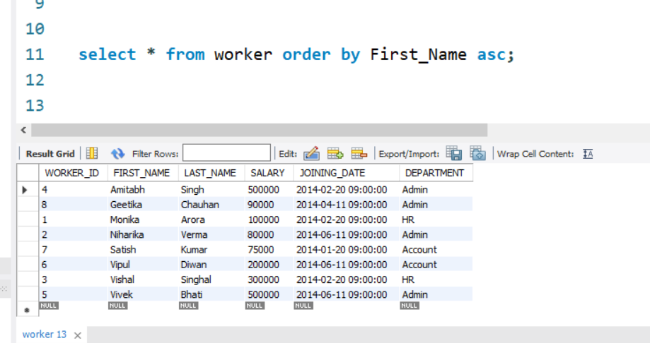

**Q-12. Write an SQL query to print all Worker details from the Worker table order by FIRST_NAME Ascending and DEPARTMENT Descending.**

**Ans:-** select * from worker order by First_Name asc,Department desc;

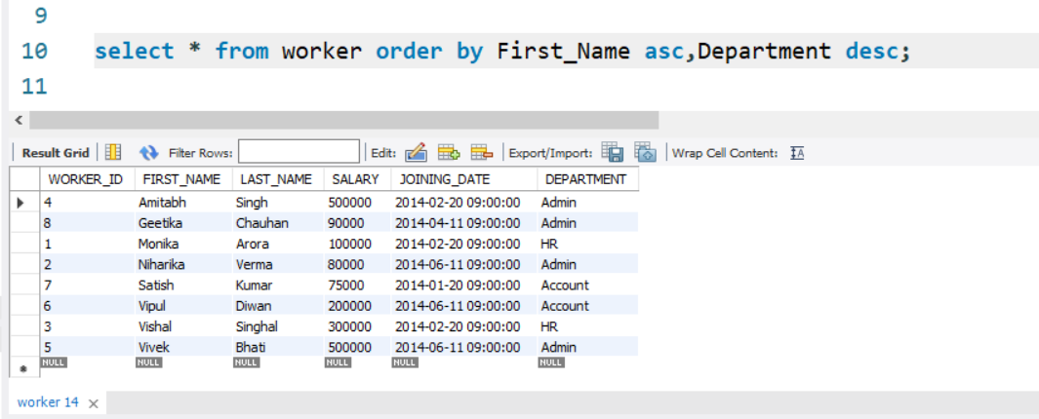

**Q-13. Write an SQL query to print details for Workers with the first names “Vipul” and “Satish” from the Worker table.**

**Ans:-** select * from worker where first_name in('Vipul','Satish');

**Q-14. Write an SQL query to print details of workers excluding first names, “Vipul” and “Satish” from the Worker table.**

**Ans:-** select * from worker where first_name not in('Vipul','Satish');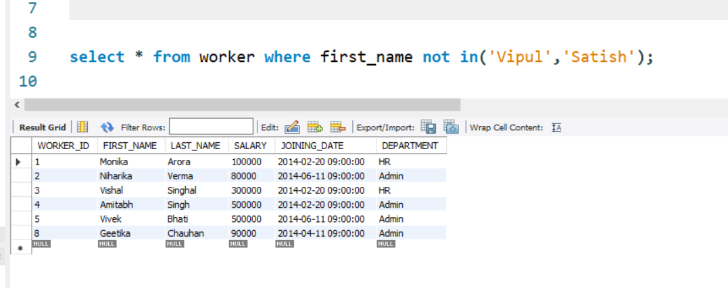

**Q-15. Write an SQL query to print details of Workers with DEPARTMENT name as “Admin”.**

**Ans:-** select * from worker where department ='admin';

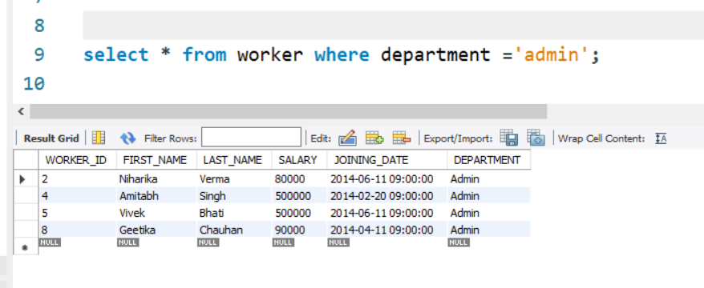

**Q-16. Write an SQL query to print details of the Workers whose FIRST_NAME contains ‘a’.**

**Ans:-** select * from worker where first_name like '%a%';

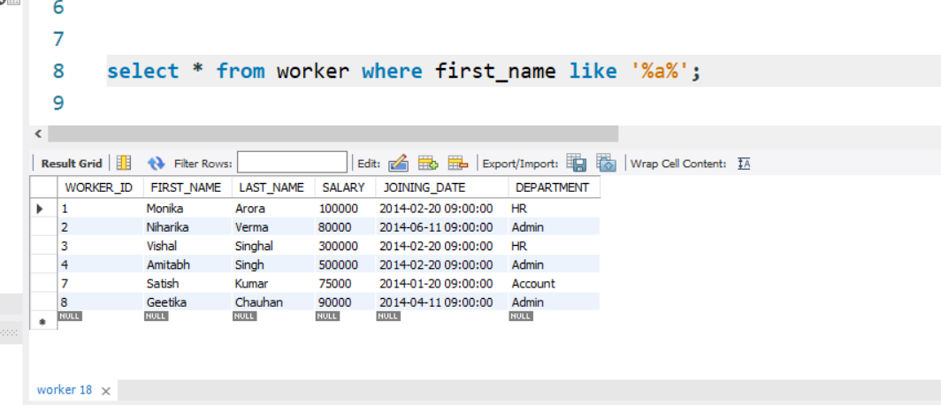

**Q-17. Write an SQL query to print details of the Workers whose FIRST_NAME ends with ‘a’.**

**Ans:-** select * from worker where first_name like '%a';

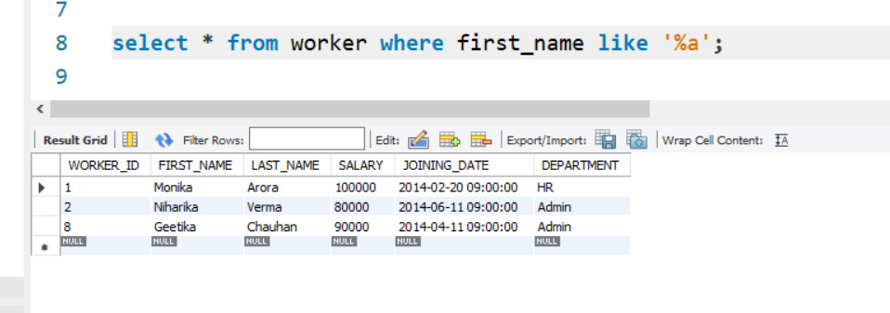

**Q-18. Write an SQL query to print details of the Workers whose FIRST_NAME ends with ‘h’ and contains six alphabets.**

**Ans:-** select * from worker where first_name like '%h' and length(first_name)=6;

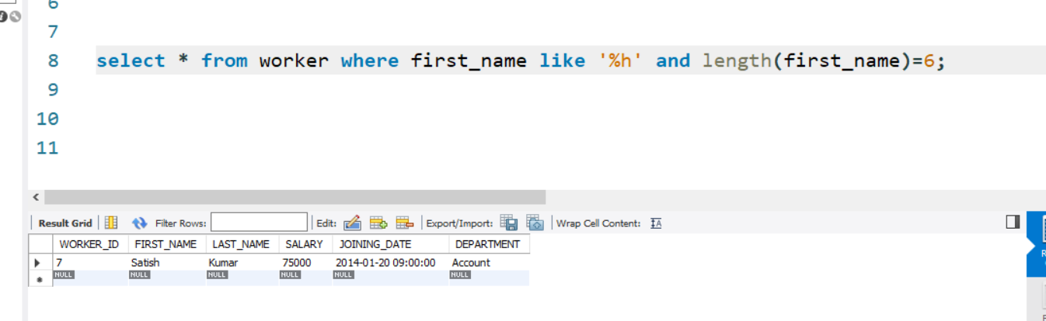

**Q-19. Write an SQL query to print details of the Workers whose SALARY lies between 100000 and 500000.**

**Ans:-** select * from worker where salary between 100000 and 500000;

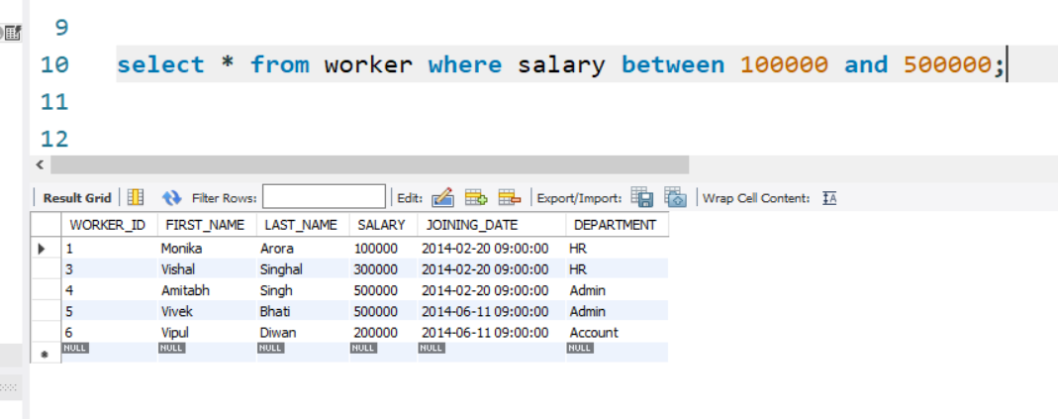

**Q-20. Write an SQL query to print details of the Workers who joined in Feb’2014.**

**Ans:-** select * from worker where year(joining_date)=2014 and month(joining_date)=2;

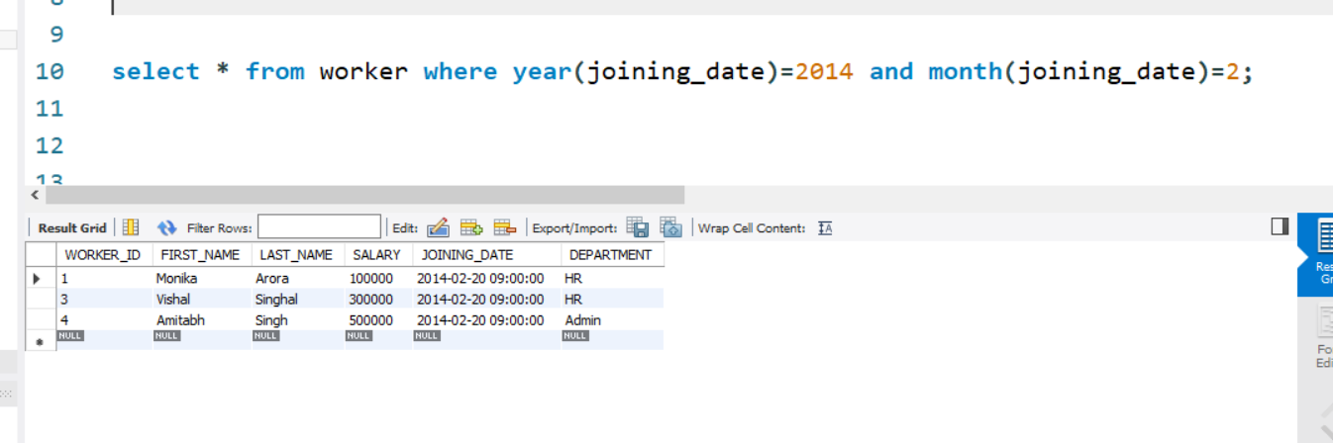

**Q-21. Write an SQL query to fetch the count of employees working in the department ‘Admin’.**

**Ans:-** select count(*) as"Admin_Worker" from worker where DEPARTMENT='Admin';

